Supplementary material – Plots of the ranked posterior distributions of the difficulty and discrimination parameters.

Ranked posterior distributions of the difficulty and discrimination parameters for the milestones within the Auditory functional domain. The plots below display the 10 easiest and 10 most difficult items and the 5 least discriminatory items.

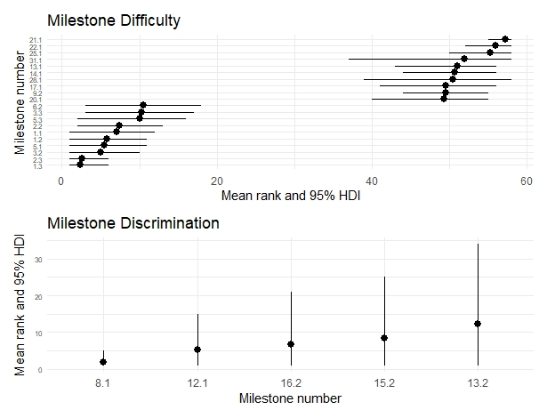

Ranked posterior distributions of the difficulty and discrimination parameters for the milestones within the Hands functional domain. The plots below display the 10 easiest and 10 most difficult items and the 5 least discriminatory items.

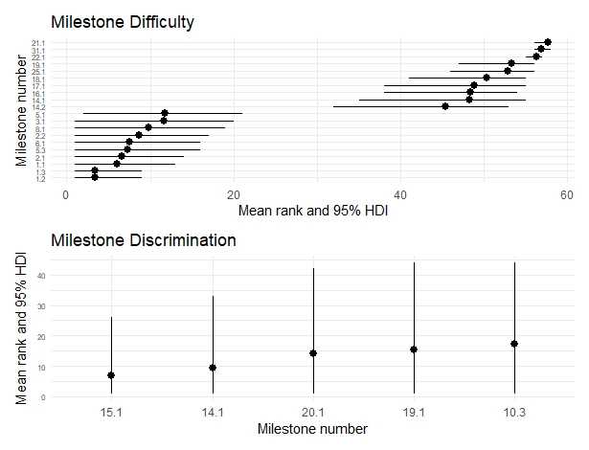

Ranked posterior distributions of the difficulty and discrimination parameters for the milestones within the Movement functional domain. The plots below display the 10 easiest and 10 most difficult items and the 5 least discriminatory items.

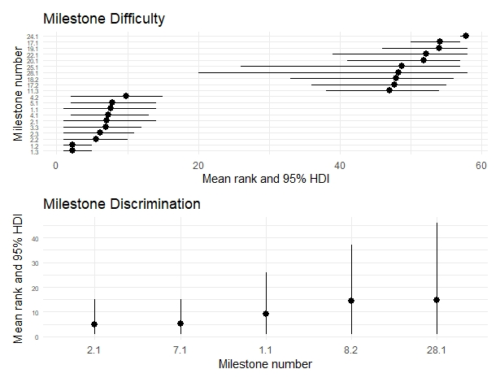

Ranked posterior distributions of the difficulty and discrimination parameters for the milestones within the Speech functional domain. The plots below display the 10 easiest and 10 most difficult items and the 5 least discriminatory items.

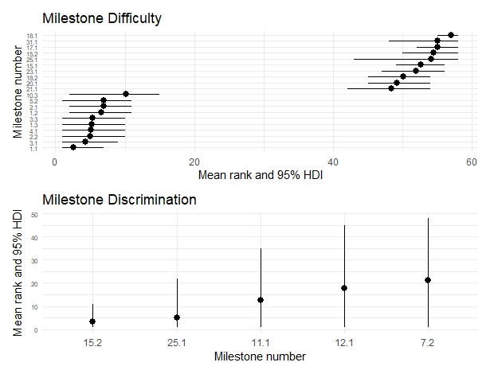

Ranked posterior distributions of the difficulty and discrimination parameters for the milestones within the Tactile functional domain. The plots below display the 10 easiest and 10 most difficult items and the 5 least discriminatory items.

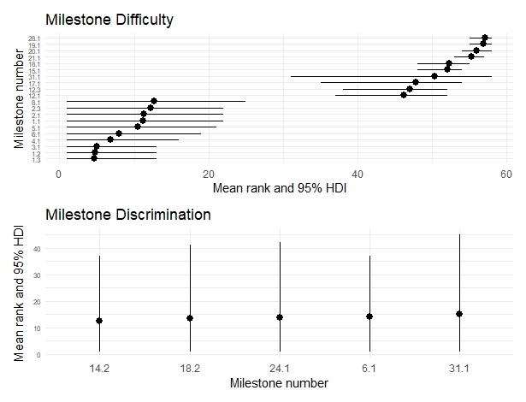

Ranked posterior distributions of the difficulty and discrimination parameters for the milestones within the Vision functional domain. The plots below display the 10 easiest and 10 most difficult items and the 5 least discriminatory items.

